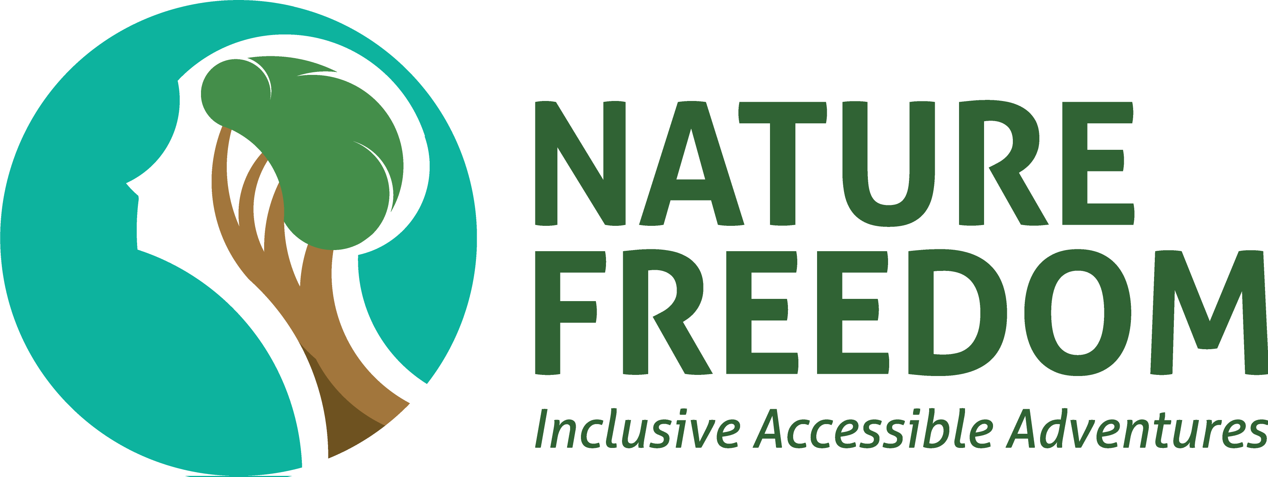

Annual Report 2023

Table of Contents

About Nature Freedom: Page 2

Founder and CEO’s Report: Page 3

Our Social Impact in 2023: Page 4

Our Growth and Performance in 2023: Page 4

Our Partners, Supporters and Sponsors: Page 5

What is happening in 2024?: Page 6

Contact Us: Page 7

About Nature Freedom

Striving for Inclusion
Nature Freedom was founded by Mathew Townsend in 2017.
Our aim is to create inclusive and accessible nature-based activities to facilitate community engagement. We further aim to provide employment opportunities within our organisation for people with disabilities.
All our activities, programs and tours are co-designed by people with disabilities and relevant community groups. We prioritise collaboration with industry, government, private and public organisations and communities to form strong partnerships and develop better ideas and methods for inclusion.

Through our partnerships and collaborations, we aim to:
- Promote inclusion in activities, communities and workplaces for people with disabilities.
- Develop co-designed integrated models for inclusion.
- Challenge approaches to gaining meaningful experiences for people with disabilities.
- Focus on lived experiences.

Founder and CEO’s Report
We are thrilled to share Nature Freedom’s incredible journey in 2023. This year has been marked by remarkable growth and accomplishments, and we are excited to provide you with a comprehensive overview.
Our Growth: Throughout the year, we have witnessed substantial growth in our organisation. We have welcomed an increasing number of NDIS clients, who have embraced our inclusive activities. Many new staff members and volunteers have also joined our team, allowing us to better serve our community.
Expanding our Activities: This year, Nature Freedom unveiled new inclusive paddling and bushwalking locations, including the picturesque Raby Bay. This has allowed us to reach more individuals. Furthermore, we have added Inclusive Green Thumbs and Cultural Tours as new activities. These allow us to cater to a broader range of interests and needs.
School Holiday and Vocational Programs: Our school holiday programs have grown thanks to our collaborations with the Brisbane, Logan, and Moreton Bay Councils. We provide enriching, inclusive experiences for participants during their school breaks. In addition, we have expanded our vocational program to more schools, promoting environmentally responsible practices to younger generations through community gardens.
Advisory Services: This year, we have introduced new advisory services in order to support tourism operators in creating accessible and welcoming experiences for individuals of all ability levels.
Recognitions and Awards: During 2023, we received multiple awards that recognise our work. In August, we were honoured with the Queensland Top 40 Under 40 Award, and in October, we received the JCI TOYP Moral and Environmental Leadership Award. These awards are thanks to the commitment of everyone in Nature Freedom, and we shall continue striving to benefit our communities and the environment.
Financial Support and Growth: Our financial growth in 2023 is thanks to the support of the Queensland Government, Brisbane City Council, and many generous donations. These funds have allowed us to enhance our website and SEO, acquire accessible paddling equipment, and recognise the invaluable contributions of our volunteers.
Looking Forward to 2024: As we look towards 2024, we anticipate another year of substantial growth. Plans are underway for the launch of a physical hub, where our clients and members can meet and foster a stronger sense of community. In addition, we are looking into establishing new community gardens, providing new experiences to our members.
In conclusion, Nature Freedom’s journey in 2023 has been nothing short of extraordinary. We extend our gratitude to everyone who has been a part of this journey, and we eagerly anticipate what 2024 will bring. Together, we will continue making nature inclusive and accessible for everyone.
Thank you for your unwavering support.

Mathew Townsend
Founder and CEO

Our Social Impact in 2023

Participants Supported: 310
NDIS Participants: 51
Volunteers: 28
Volunteer Hours: 277
Paid Staff: 5
Staff and Volunteers with Disabilities: 3
Partners: 8
Media Engaged: 11

Our Growth and Performance in 2023
Inclusive Paddling Events: 11
Inclusive Bushwalking Events: 9
Inclusive Green Thumbs and Crafts Events: 2
Inclusive Cultural Tours: 2
School Holiday Activities: 25
Community Garden Projects: 5
Sponsors: 2
Donors: 4
Fundraisers: 2

Our Partners, Supporters and Sponsors

Active and Healthy Provider Partners:
Brisbane City Council
City of Logan
City of Moreton Bay

Inclusive Activity Partners:
All About Paddling
Bay Island Water Sports
Northey Street City Farm
Yura Tours

Group Booking Partners:
the Y
Busy Schools

Our Supporters:
Queensland Government
Brisbane Economic Development Agency

Our Sponsors and Clients:
The Social Deck
The Karma Collective

Individuals:
Cr Ryan Murphy
Ross Vasta MP
Steve Minnikin MP

What is happening in 2024?
- More Inclusive Tour Experiences, including full day and double activities
- Growing our Group Bookings Program
- Opening a potential mini community hub
- Active & Healthy Programs (Brisbane, Moreton Bay and Logan Council areas)
- Community Gardens Program for schools
- Work experience and volunteer programs for people with disabilities
- Watch this space!

Contact Us
Website: https://naturefreedom.org.au
Email: info@naturefreedom.org.au
Facebook: https://www.facebook.com/naturefreedom
Instagram: https://instagram.com/naturefreedom_aus
LinkedIn: https://www.linkedin.com/company/nature-freedom

